Table S1. AESNN3 values learning from alignments.
Amino acids | Values1 | Values2 | Values3
A | -0.99 | -0.61 | 0.00
R  N  D  C  Q  E  G  H  I  L  K  M  F  P  S  T  W  Y  V | 0.28  0.77  0.74  0.34  0.12  0.59  -0.79  0.08  -0.77  -0.92  -0.63  -0.80  0.87  -0.99  0.99  0.42  -0.13  0.59  -0.99 | -0.99  -0.24  -0.72  0.88  -0.99  -0.55  -0.99  -0.71  0.67  0.31  0.25  0.44  0.65  -0.99  0.40  0.21  0.77  0.33  0.27 | -0.22  0.59  -0.35  0.35  -0.99  -0.99  0.10  0.68  -0.37  -0.99  0.50  -0.71  -0.53  -0.99  0.37  0.97  -0.90  -0.99  -0.52

Table S2. Comparison results of different parameters of iACP-DSFRA on the training dataset.
 | Sp (%) | Sn (%) | Acc (%) | MCC (%) | AUC (%)
filter number = 32 | 97.39 | 79.48 | 88.44 | 78.83 | 96.05
filter number = 64 | 96.32 | 84.60 | 90.46 | 81.94 | 96.63
filter number = 256 | 96.02 | 85.59 | 90.80 | 82.44 | 97.05
kernel size =(1,1,1) | 92.50 | 83.57 | 88.04 | 76.81 | 94.20
kernel size =(1,2,3) | 96.31 | 83.99 | 90.15 | 81.22 | 96.60
Dense(activation = tanh) | 98.46 | 75.89 | 87.18 | 76.71 | 97.28
L2=0.01 | 91.84 | 86.64 | 89.24 | 78.87 | 94.35
Learning_rate=0.001 | 89.66 | 88.49 | 89.07 | 78.54 | 94.07
iACP-DSFRA | 96.84 | 87.77 | 92.30 | 85.34 | 97.01

Table S3. Comparison results of different parameters of LightGBM on the training dataset.
 | parameters | Sp (%) | Sn (%) | Acc (%) | MCC (%) | AUC (%)
ProtBert_BFD | LightGBM-1>1* | 96.46 | 81.53 | 88.99 | 79.35 | 96.97
ProtBert_BFD | LightGBM-1>2 | 97.41 | 79.60 | 88.51 | 78.77 | 97.74
ProtBert_BFD | LightGBM-1>3 | 97.36 | 79.13 | 88.25 | 78.25 | 97.38
APACB | LightGBM-2>1 | 87.42 | 92.11 | 89.77 | 80.31 | 95.90
APACB | LightGBM-2>2* | 88.27 | 93.06 | 90.66 | 82.02 | 95.84
APACB | LightGBM-2>3 | 88.68 | 91.31 | 89.99 | 80.72 | 95.61
LightGBM | Boosting_type= gbdt* | 96.84 | 87.77 | 92.30 | 85.34 | 97.01
LightGBM | Boosting_type= dart | 96.78 | 85.33 | 91.05 | 83.10 | 97.12
LightGBM | Boosting_type= goss | 98.14 | 85.09 | 91.62 | 84.24 | 97.73

Table S4. Hyperparameter details of layers in the iACP-DSFRA model.
Layers | Hyperparameter Settings
Input_pro | input dim = (None,308,1)
Block_1 | kernel size_1 =1, filter number = 128, activation = relu, l₂=0.001
Block_2 | kernel size_2 =3, filter number = 128, activation = relu, l₂=0.001
Block_3 | kernel size_3 =5, filter number = 128, activation = relu, l₂=0.001
Dense_1 | (128, activation = relu)
Input_APACB | input dim = (None,343)
Dense_2 | (343, activation = softmax)
Dense_3 | (256)
Dense_4 | (128, activation = relu)
Dense_5 | (256, activation = relu)
Dropout | 0.1
Dense_6 | (1, activation = sigmid)
Learning_rate | 0.0001
loss | binary_crossentropy

Table S5. Hyperparameter details of the LightGBM.
 | Hyperparameter Settings
Boosting_type | gbdt
Objective | binary
Number_leaves | 31
Learning_rate | 0.05
N_estimators | 100

Table S6. The 95% confidence interval and p-value of the results from the training dataset.
 | Acc (%) | MCC (%) | AUC (%)
1 | 92.81 | 86.26 | 96.34
2 | 90.92 | 82.76 | 96.60
3 | 92.16 | 85.26 | 97.47
4 | 91.72 | 84.21 | 96.82
5 | 93.90 | 88.21 | 97.80
95%CI | [91.24, 93.36] | [82.78, 87.9] | [96.25,97.76]
p-value  (threshold=0.05) | 0.4964 | 0.7312 | 0.9835

Table S7. The 95% confidence interval and p-value of the results from the independent test dataset.
 | Acc (%) | MCC (%) | AUC (%)
1 | 94.74 | 89.48 | 97.79
2 | 92.11 | 84.54 | 97.51
3 | 92.69 | 85.91 | 96.32
4 | 92.11 | 84.22 | 96.87
5 | 93.57 | 87.74 | 98.16
95%CI | [91.65, 94.44] | [83.62, 89.14] | [96.42, 98.24]
p-value  (threshold=0.05) | 0.9343 | 0.7229 | 0.3726

Table S8. Comparison with the existing models on the independent test dataset in study [6].
Methods | MCC (%) | Sn  (%) | Sp  (%) | PRE  (%) | Acc  (%) | AUC  (%) | F1-score (%)
iACP-DFSRA | 66.1 | 81.3 | 90.4 | 65.3 | 88.8 | 90.6 | 72.4
mACPpred 2.0 | 59.7 | 80.7 | 86.8 | 57.5 | 85.7 | 88.7 | 67.1
iAMPCN | -21.3 | 62.5 | 15.6 | 14.1 | 24.1 | 68.1 | 23.0
mACPpred | 48.9 | 75.4 | 81.9 | 47.9 | 80.7 | 84.2 | 58.6
MLACP 2.0 | 55.7 | 79.2 | 84.9 | 53.6 | 83.8 | 89.3 | 63.9
ACP-MHCNN (740) | 13.2 | 35.7 | 78.9 | 27.2 | 71.1 | - | 30.9
ACP-MHCNN  (500/164) | -10.2 | 16.7 | 71.6 | 11.5 | 61.6 | - | 13.6
ACPred-BMF  (Main) | 19.8 | 67.2 | 58.4 | 26.3 | 60.0 | 32.6 | 37.8
ACPred-BMF  (Alternate) | 25.1 | 44.1 | 82.9 | 36.4 | 75.9 | 26.3 | 39.9
ACPred | 27.8 | 51.0 | 80.4 | 36.5 | 75.1 | 73.9 | 42.6
AMPfun | 42.9 | 76.9 | 75.8 | 41.2 | 76.0 | 80.2 | 53.7
iAMP-RAAC | 10.2 | 6.6 | 97.9 | 40.8 | 81.4 | - | 11.3
AntiCP 2.0  (Main) | 17.8 | 43.3 | 77.2 | 29.5 | 71.0 | 59.7 | 35.1
AntiCP 2.0  (Alternate) | 47.2 | 60.5 | 88.7 | 54.3 | 83.6 | 83.5 | 57.2
CancerGram | 11.0 | 6.6 | 98.1 | 43.5 | 81.5 | 67.3 | 11.4
iDACP  (Sp of 90%) | 25.5 | 20.3 | 96.3 | 54.6 | 82.5 | 85.2 | 29.6
iDACP  (Sp of 80%) | 33.0 | 35.6 | 92.7 | 51.9 | 82.4 | 85.2 | 42.2
iDACP  (Sp of 70%) | 38.0 | 48.4 | 89.2 | 49.7 | 81.8 | 85.2 | 49.0
iDACP  (Sp of 60%) | 44.0 | 61.6 | 86.1 | 49.5 | 81.7 | 85.2 | 54.9
iDACP  (Sp of 50%) | 45.1 | 68.0 | 83.3 | 47.4 | 80.5 | 85.2 | 55.9
TriNet | 22.9 | 43.3 | 81.7 | 34.3 | 74.7 | 71.8 | 38.3
PreTP-2L | 6.5 | 02.1 | 99.4 | 44.8 | 81.8 | - | 04.1

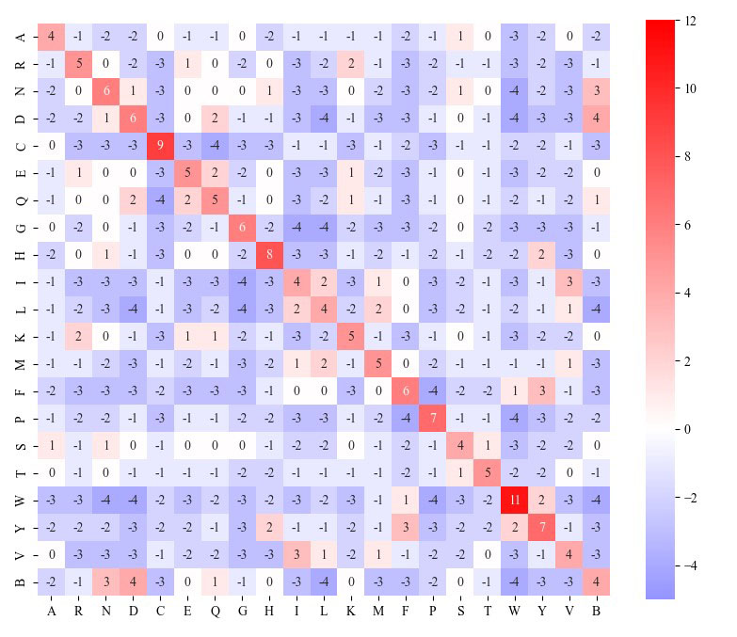
Figure S1. The BLOUSM62 scoring matrix heat map.

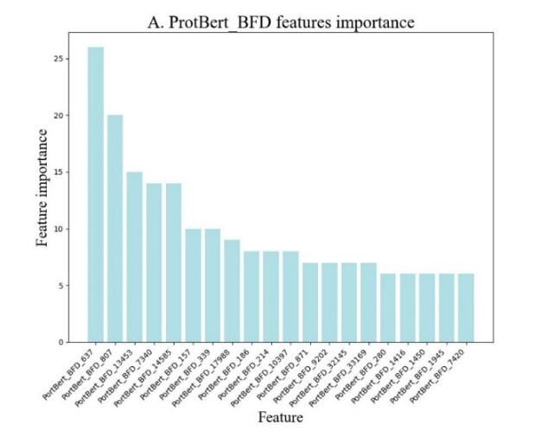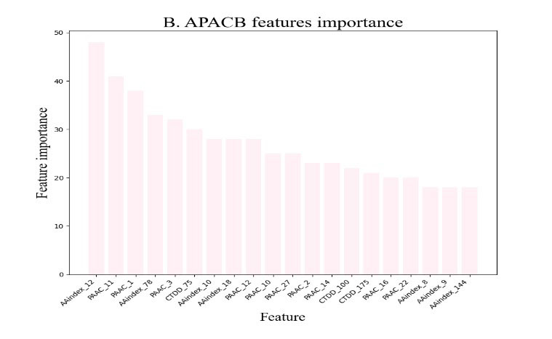
Figure S2. A) the top 20 features of ProtBert_BFD ranked by LightGBM-1; B) the top 20 features of APACB ranked by LightGBM-2.

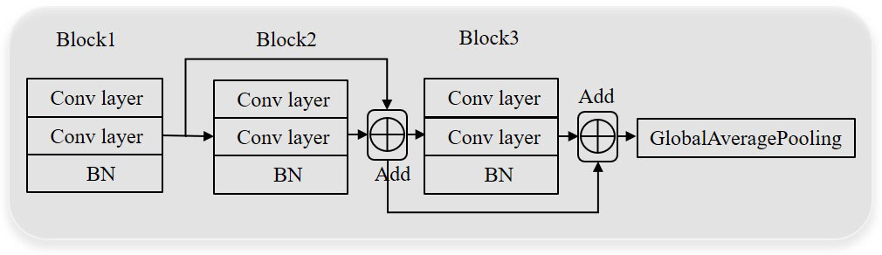
Figure S3. Structure of the ResCNN model.

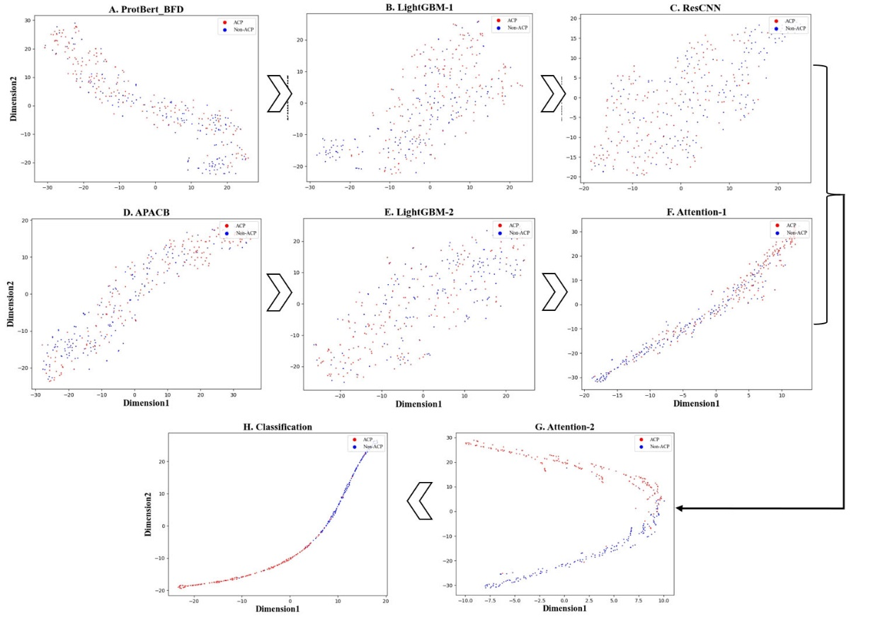
Figure S4. The t-SNE layer visualization of the iACP-DFSRA model on the independent dataset.
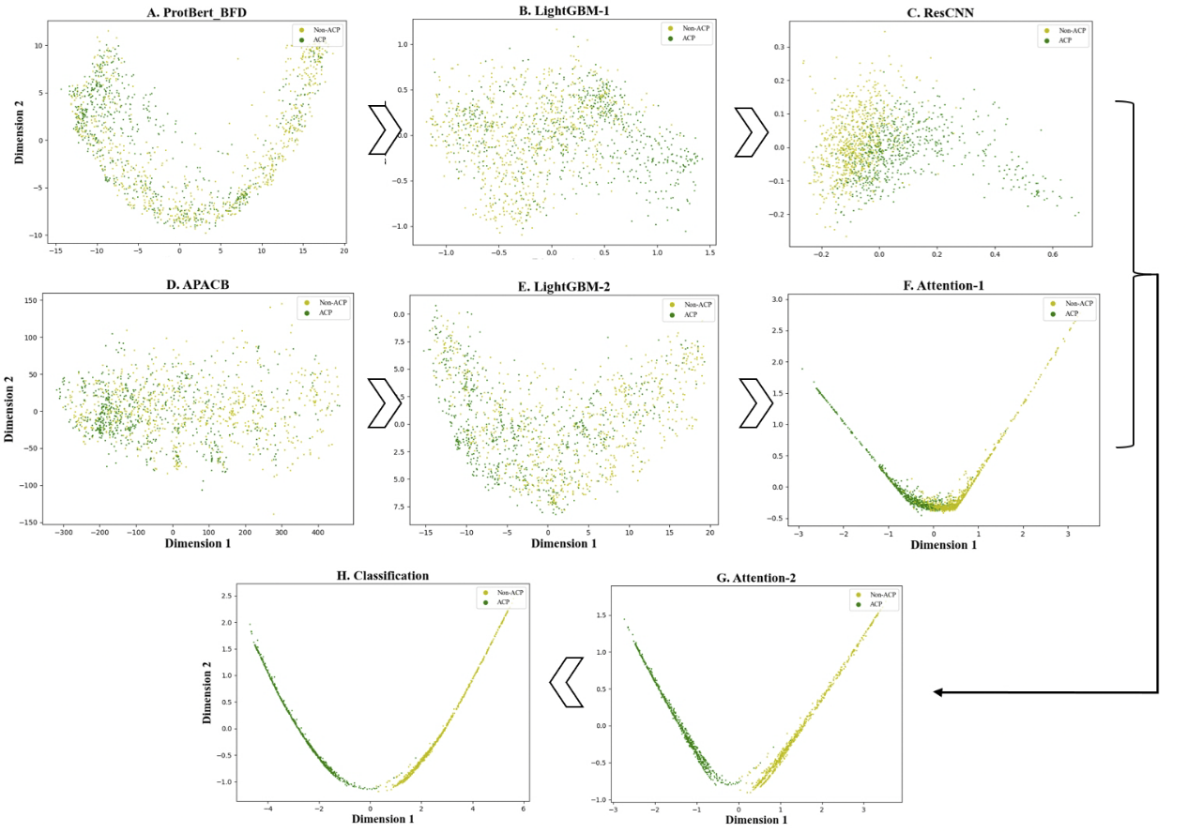
Figure S5. The PCA layer visualization of the iACP-DFSRA model on the training dataset.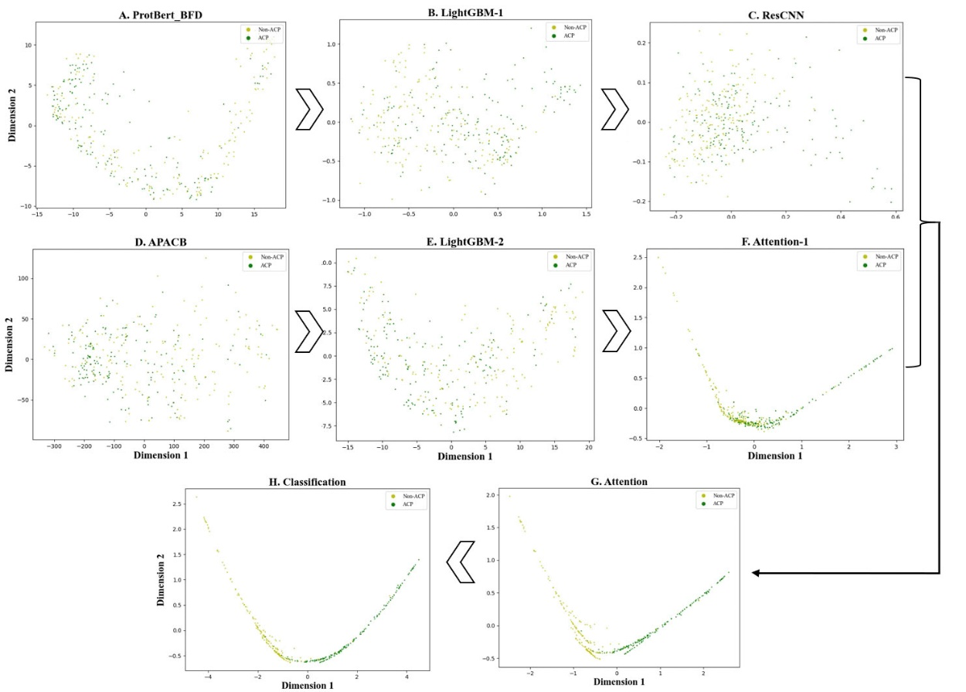
Figure S6. The PCA layer visualization of the iACP-DFSRA model on the independent dataset.
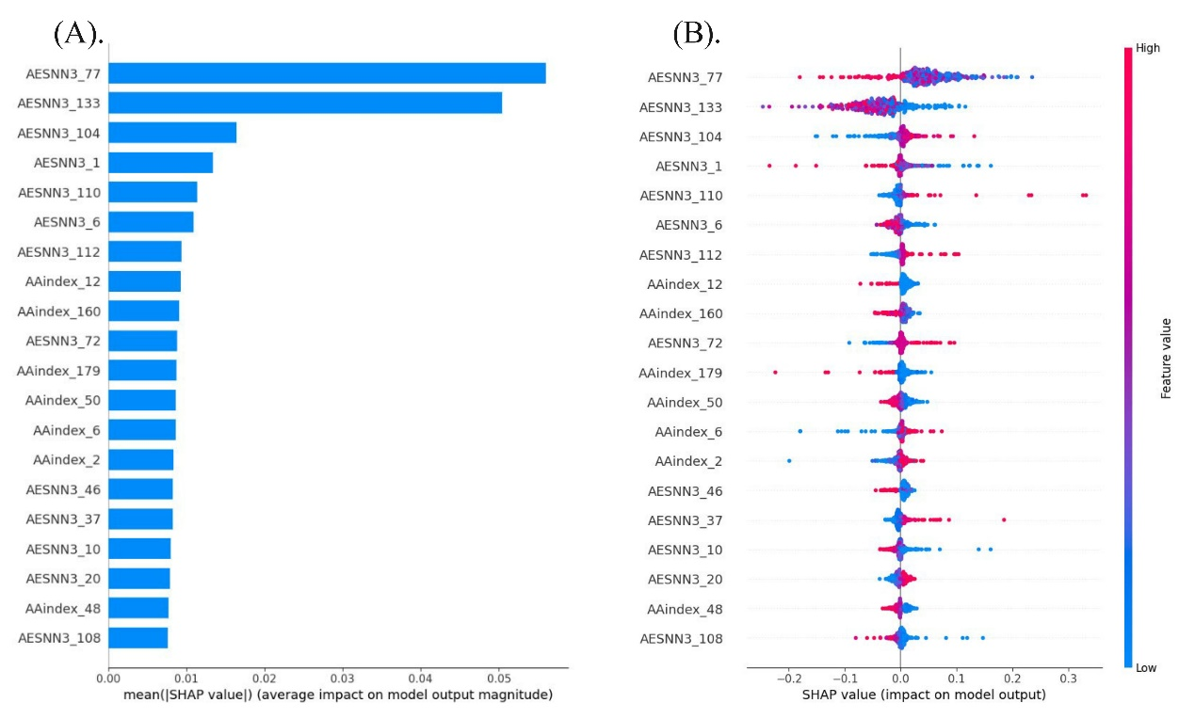
Figure S7. A visual depiction of the model interpretation and analysis of feature contributions for the five categories of handcrafted features is presented. (A) The influence of the top 20 features on model predictions is illustrated. (B) SHAP values for the leading 20 feature descriptors are provided.

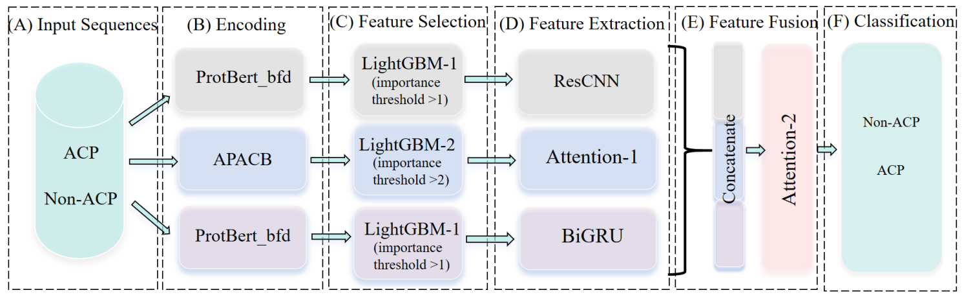
Figure S8. The general structure of multi-channel-1.
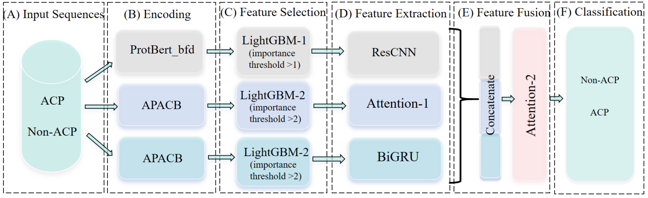
Figure S9. The general structure of multi-channel-2.

